**Voyage Vista: Illuminating Insights From Uber Expenditinory Analysis**

1.Introduction:

1.1 Overview

Uber is a multinational transportation network company that operates a ride-hailing platform. It was founded in 2009 by Garrett Camp and travis Kalanick and is based in San Francisco, California. Uber provides a convenient way for individual’s to request rides from drivers who use their own personal vehicles. Uber Drives Analysis refer to the Analyzing the number of tripes taken by uber drivers can provides insights into their overall activity and the demand for rider in specific areas. Daily Weekly, monthly Analysis: Uber data can be analyzed on a daily weekly, monthly basic to understand the trends and patterns of trips volumes. This analysis can help identify peak hours of days of high demand and optimize driver availability during those times. Trips can be analyzed based on geographic regions or specifc cities to identify areas with highter demand.This analysis can help Uber drivers decide where to focus their driving efferots for maximum efficientcy and profitabelly. The major of our project is to use data analysing techniques to find unknown patterns in the Uber Drives dataset. The research is carried out on Uber drives daa collected from the year 2016.

1.2) Purpose

Vista Voyage – your journey, our Expertise with over 8 year of Nevigating the travel world,we’re the sequad that keeps a watchful eye on every twist and turn in the travel universe. From

flight rule we’re here to ensure you don’t pay a king’s ransom for your adventures our destination knowledge is thecompass that guarantes a hossle- free trip through every twist and turn .

2. Problem definition and design things:

2.1 Empathy map

2.2 Brainstroming

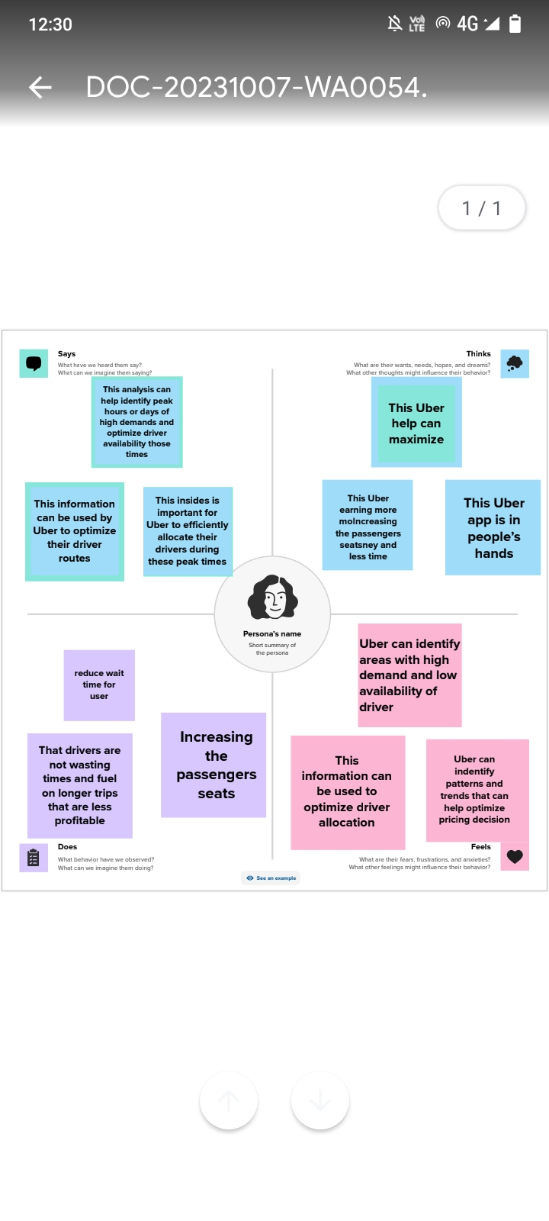

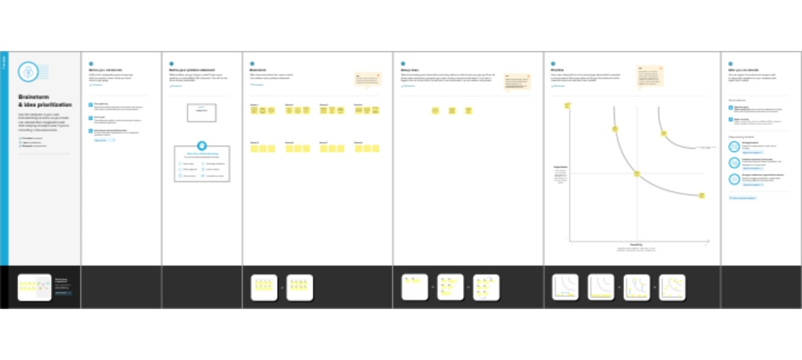

3. Result

Data visualization

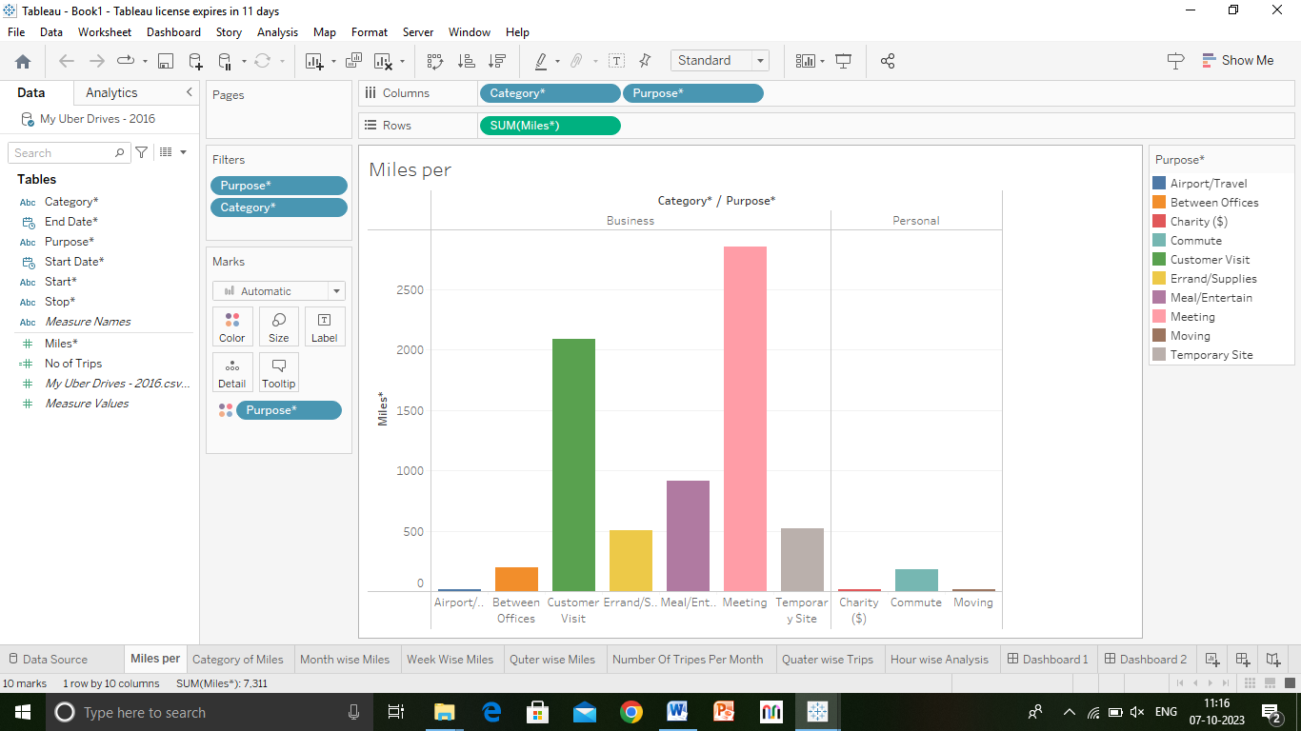

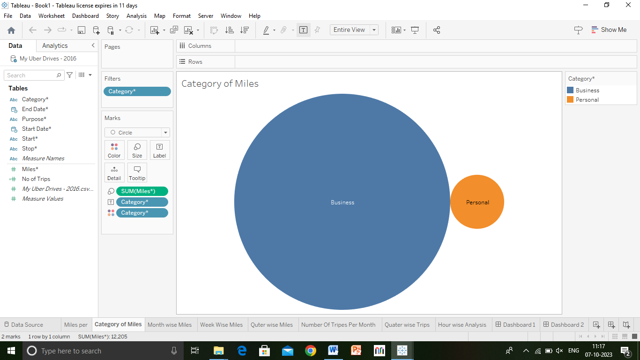

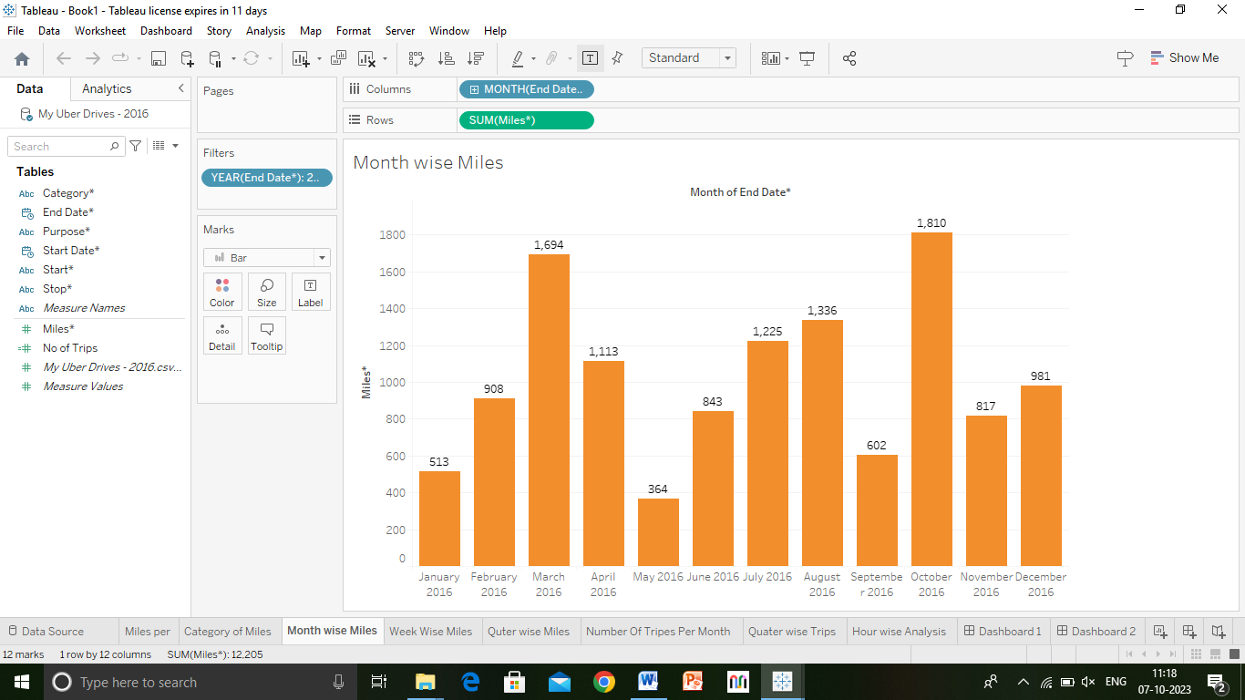

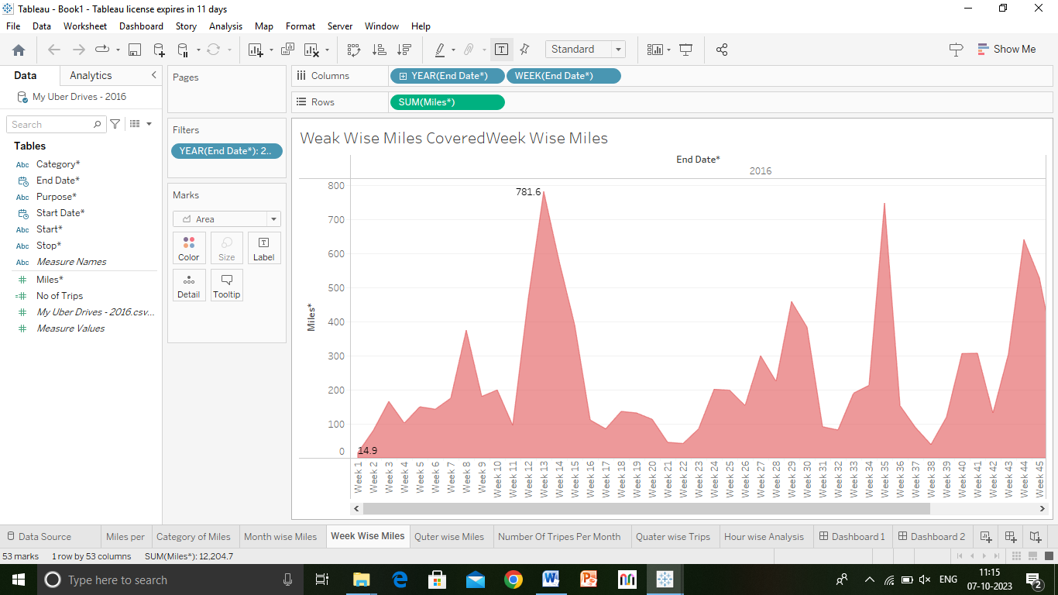

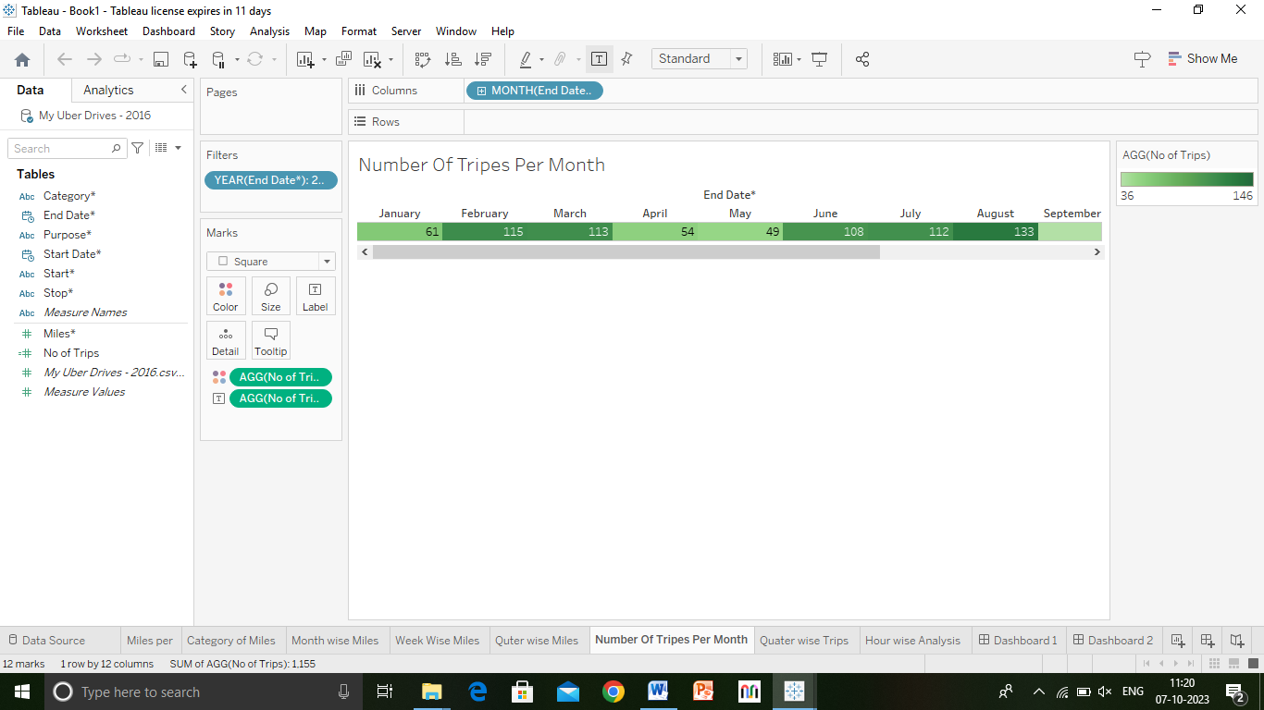

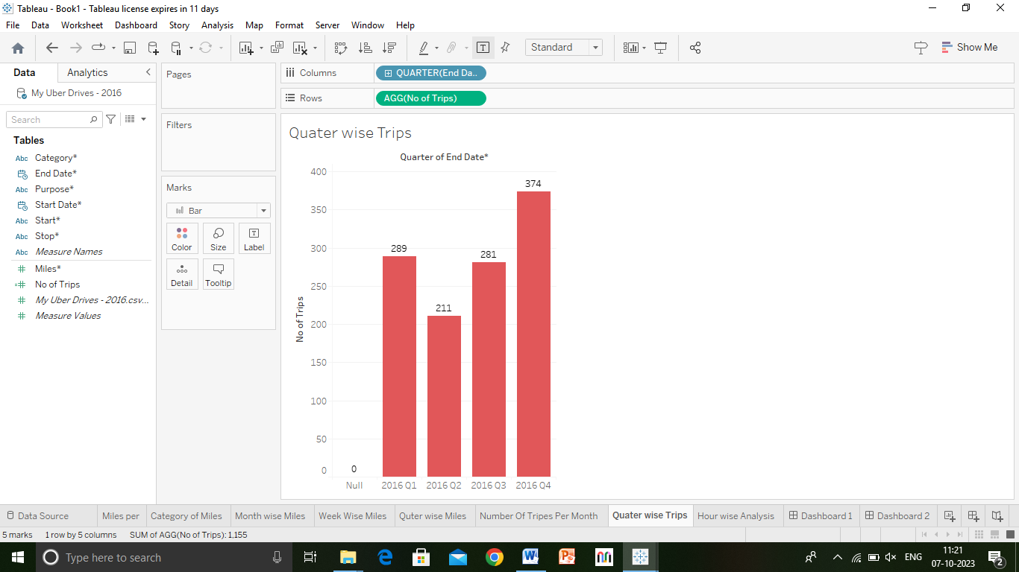

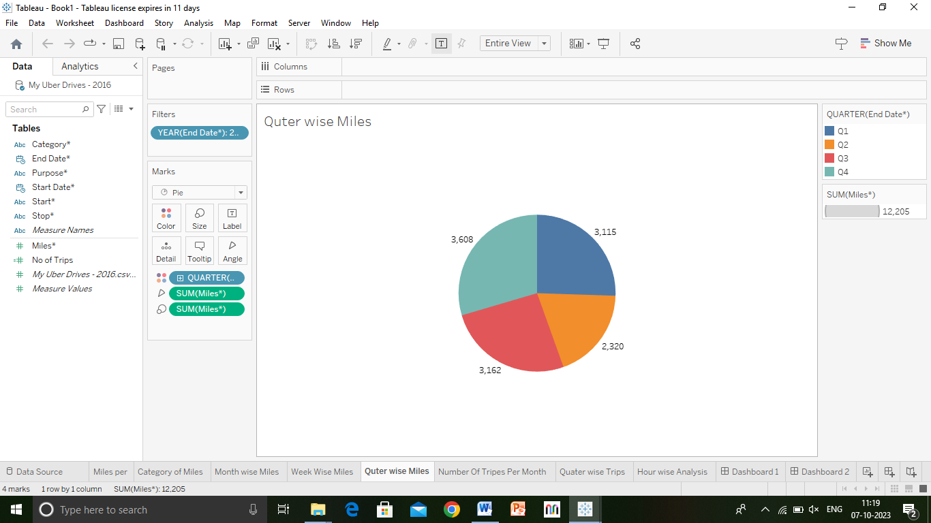

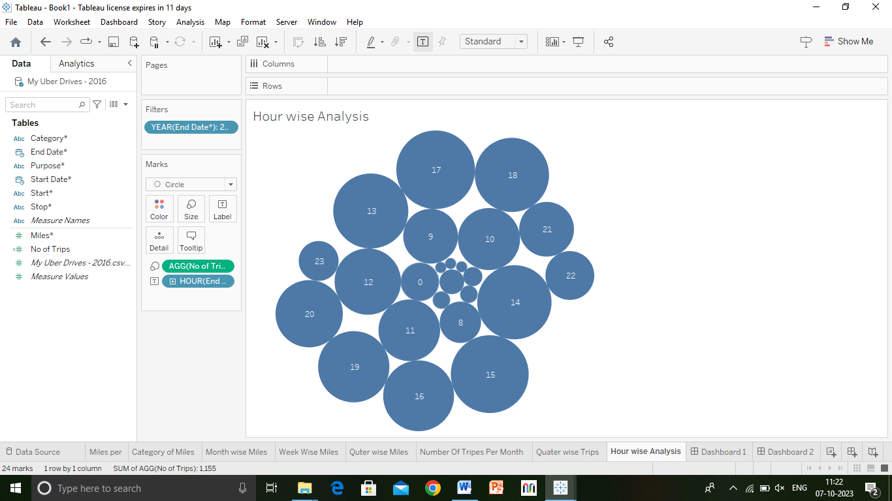

Dashboard:

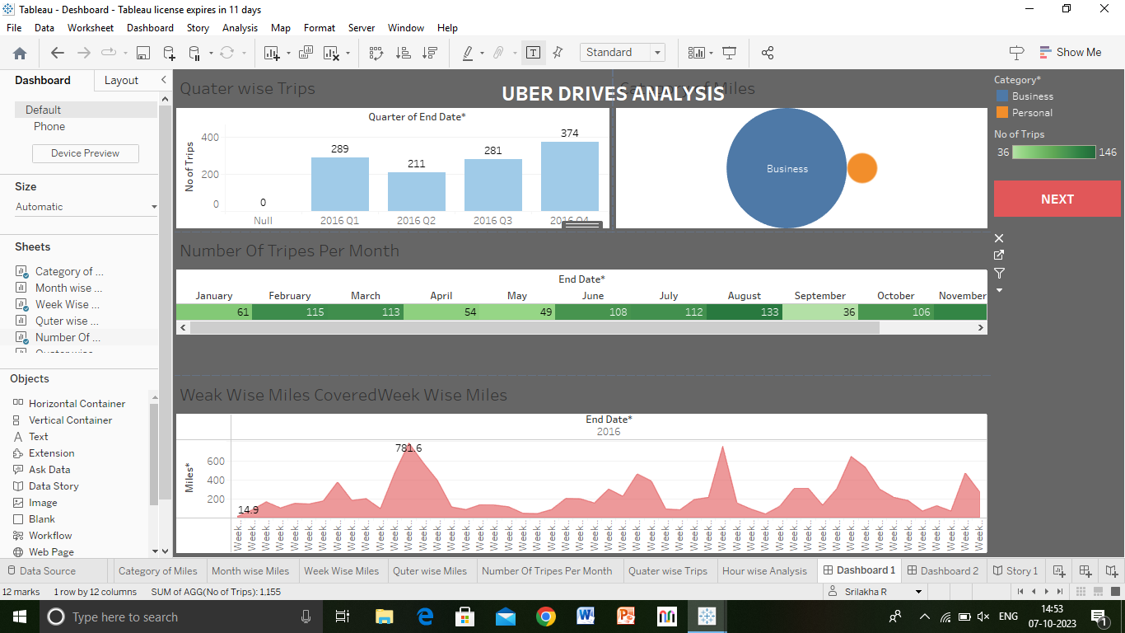

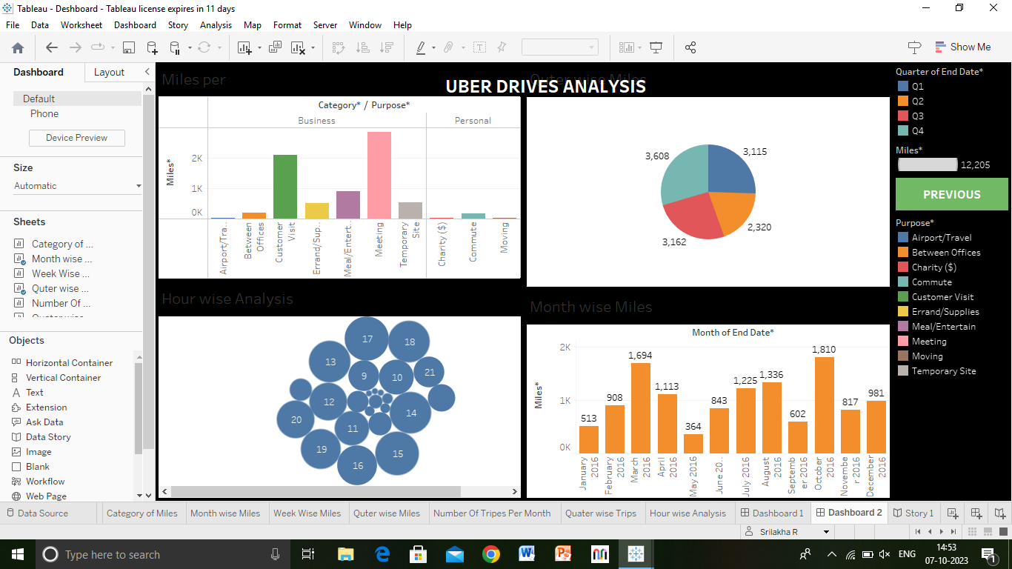

Story:

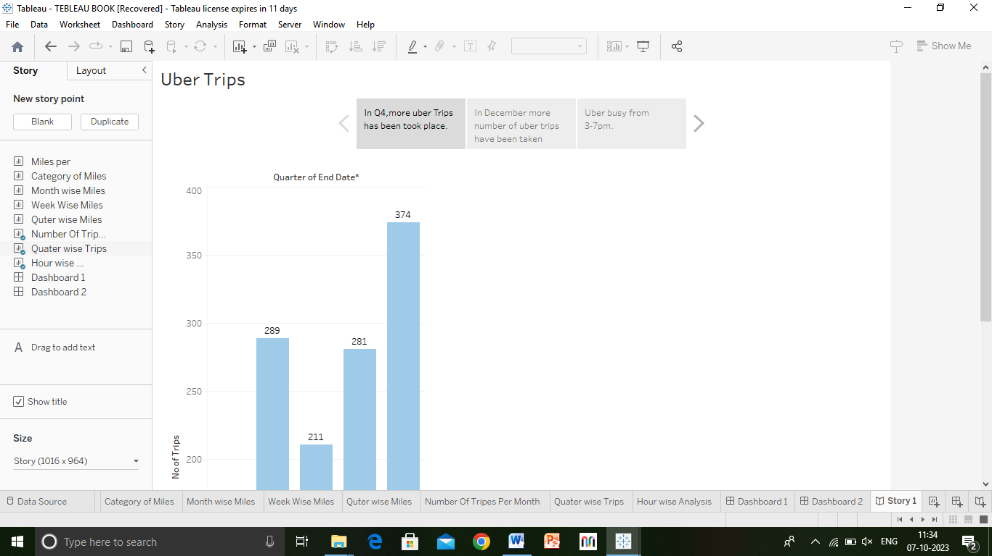

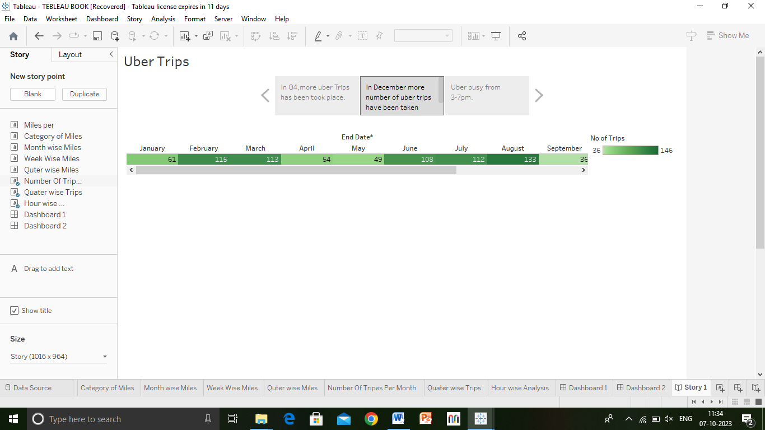

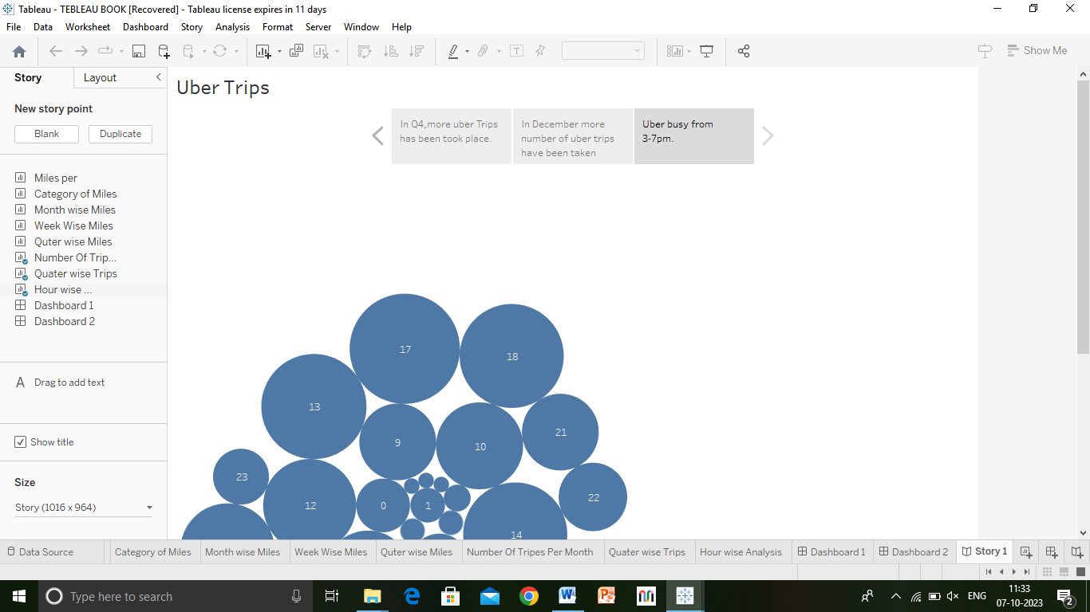

4) Advantage And Disadvantage:

Advantage:

I ) Detailed explanatory exlendable, adaptable personalization

II) Little data needed easynto compute personalization.

III) Potential for global coverge existing methods.

IV) Simple discrimination task strong personatlization feedback mechanism.

V) Dedicated approach truly uniform covrage personalization .

DISADVANTAGE:

I ) Data intensive Parameter turing transfer to ofter types.

Ii) Evry individual treated he same ambigioues calegories depends on classification scheme.

III ) Biased data suitability issues.

IV) Dependency on base data dedicated user base

APPLICATION OF VOYAGE VISTA:

Any person, who vista our platform, inquires about our purchases any products or servies of vista voyage through our website, mobile applications, sales persons, officers, call centers, agents, Travel Experts, or any of the other sales channels, agree to be governed by these Terms. If you do not agree with any art of this Agreement then you must not avail vista voyage’s services and must not accessor approach the sales channels of vista voyage. All rights and liabilities of the user and vista voyage with respect to any services or product facititated by vista voyage shall be restricted to the scope of these term.

CONCLUSION:

We aim to consolidate and grapple with the challenge of how we,as peace psychologist, researchrs,educatore, practitioners and policy makers can permeate an understanding of social identity into the mainstream. First,we bring together the themes that we believe summarise the contribution of our book to social identity, peace and confict. Second, we consider the importance of the historical and socio-political context in providing a coherent understanding of social identity’s role in promoting positive peace and developing preventive measure.

Future Scope:

I ) Conduct end to-end accounts & finance

function in the production department.

II) process vendor payments, vendor reconciliation, epense booking& bill booking .

III)Making daily MIS rports& order management.

IV) Prepare an expense budget report.

V) Provide ongoing accounding and reporting support.

VI)Review and release online banking payments.

VII) prepare monthly financial reports.3